Lab Manual: Setting Up a Docker-Based Lab Environment for Ubuntu, Kali Linux, and OWASP Juice Shop
Assignment Title: Create a Lab Setup Using Docker Containers for Ubuntu, Kali Linux, and OWASP Juice Shop
Objective: This lab manual guides you through creating a complete virtual security lab using Docker. You will set up three isolated yet interconnected containers:
- Ubuntu (general-purpose Linux environment)
- Kali Linux (penetration testing / attacker machine)
- OWASP Juice Shop (vulnerable web application for practicing security testing)
You will learn Docker basics, container management, and how to interact between containers (e.g., attacking Juice Shop from Kali). This setup is ideal for cybersecurity assignments, ethical hacking practice, and demonstrating containerization.

1. Introduction to Docker and the Lab Architecture
Docker allows you to run lightweight, isolated environments (containers) without installing full virtual machines.
Lab Architecture (High-Level):
- All containers will run on your host machine (Windows, Mac, or Linux).
- We will create a custom Docker network so Kali can reach Juice Shop by container name (e.g., http://juice-shop:3000).
- Ubuntu acts as a utility machine.

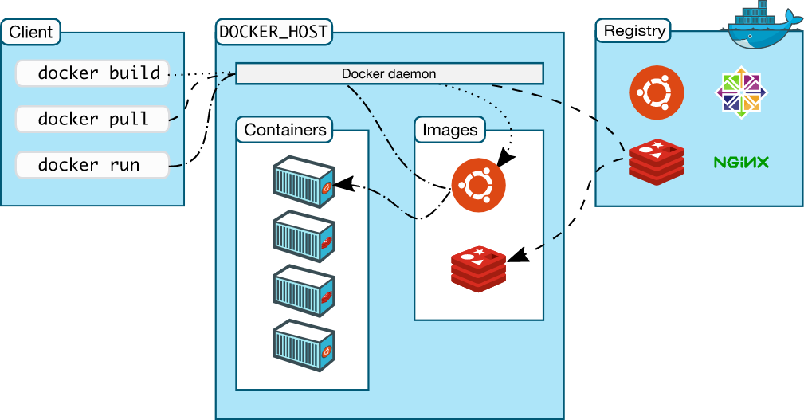
Docker Architecture Diagram (above) – Client commands → Docker daemon → Images → Running Containers.
2. Prerequisites For Installing Docker Container :
- A computer with at least 8 GB RAM and 20 GB free disk space.
- Stable internet connection (for pulling images).
- Administrator rights on your host machine.
- No prior Docker knowledge required – everything is explained step-by-step.
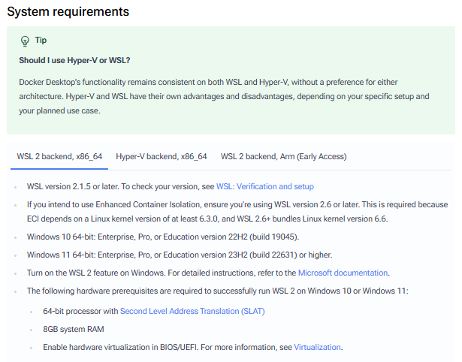

3. Step 1: Install Docker Desktop on Your Host Machine
Docker Desktop is the easiest way to get started (includes Docker Engine, CLI, and GUI).

For Windows / Mac (Recommended):
- Go to https://www.docker.com/products/docker-desktop/
- Click Download for Windows or Download for Mac.
- Run the installer.
- During setup, enable WSL 2 (Windows) or allow Docker to install required components (Mac).
- Restart your computer when prompted.
- Open Docker Desktop – it should show “Docker Engine is running”.
Screenshot of Docker Desktop Installation Page (Windows)

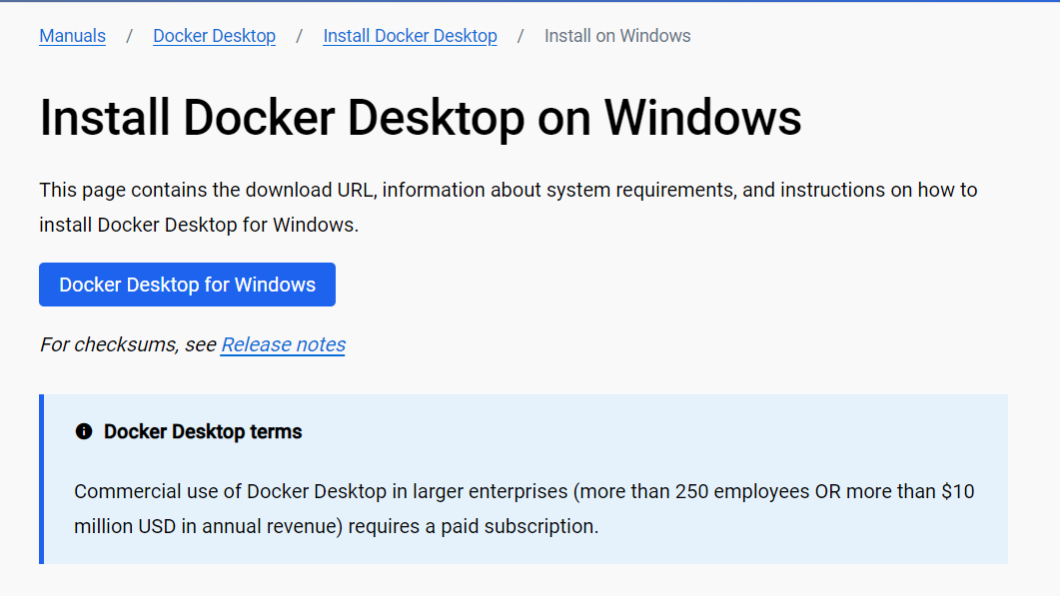

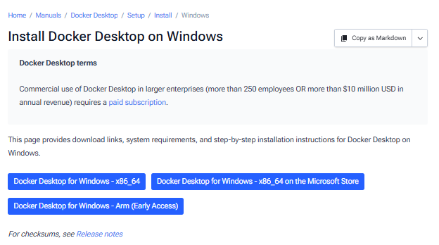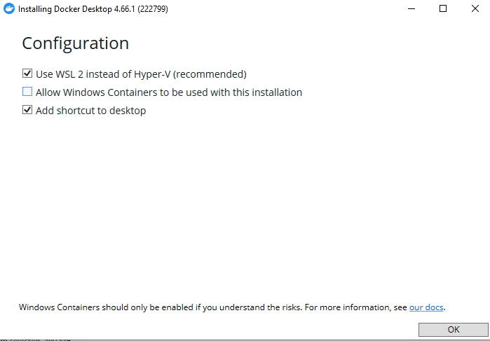

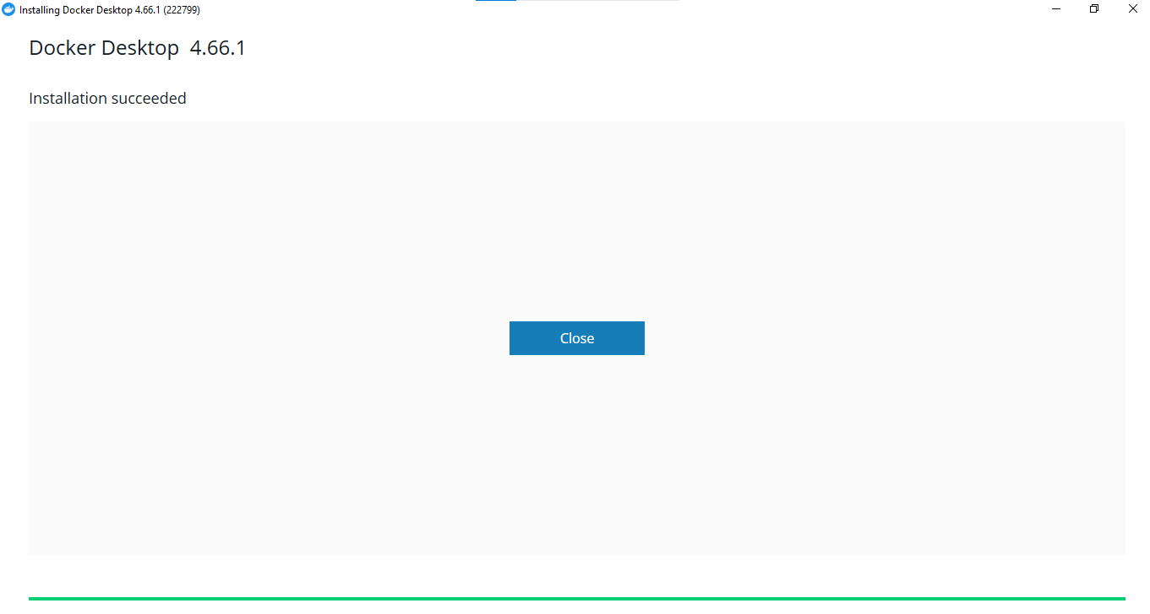


4. Basic Docker Workflow (Step-by-Step)

Step 1: Search for an Image
docker search <image_name>
Example:
docker search kali
Purpose: Finds images on Docker Hub.
You can also search for image name on Docker Hub website as we did in class room

Step 2: Download (Pull) an Image
docker pull <image_name>
Examples:
docker pull kalilinux/kali-rolling
docker pull ubuntu
docker pull bkimminich/juice-shop

Purpose: Downloads image from Docker Hub to your system.
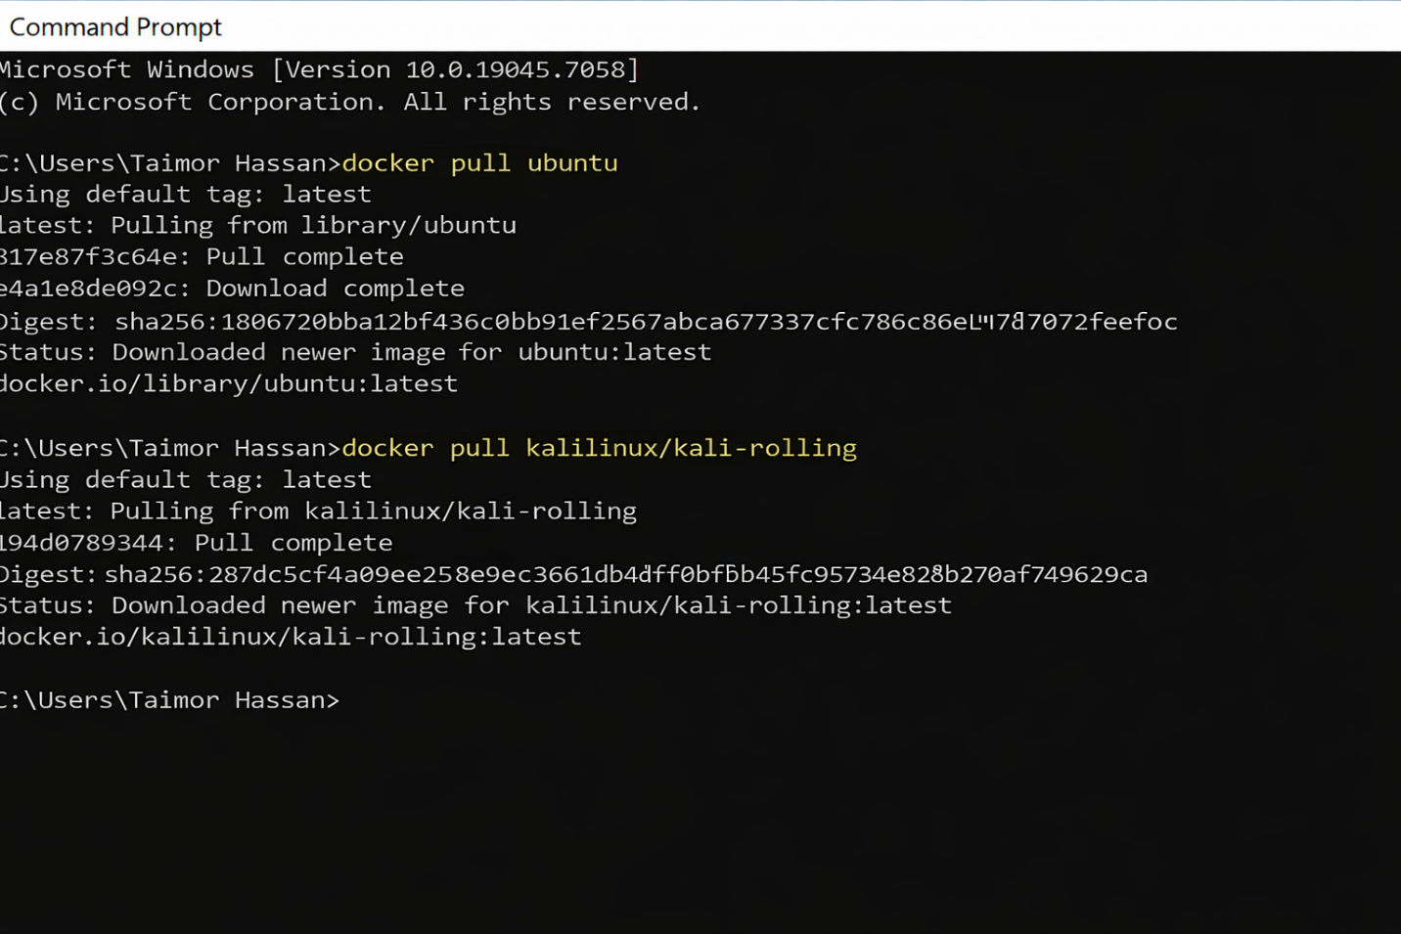
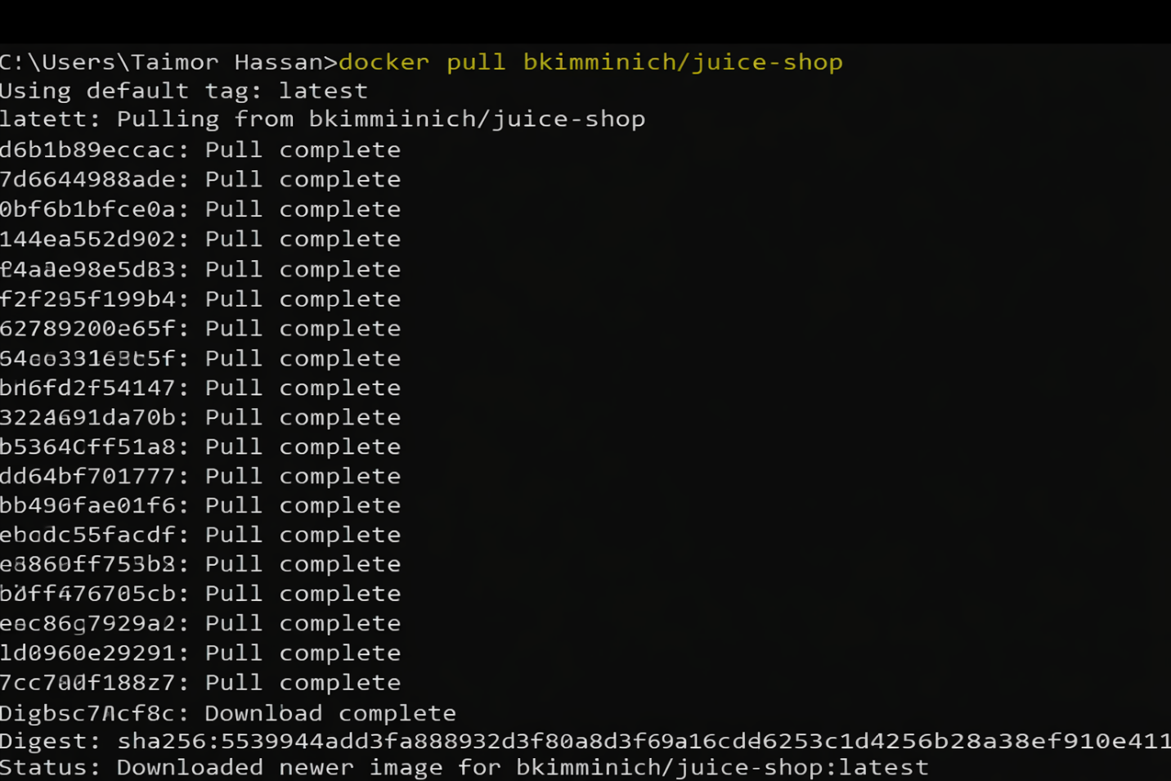

Docker Container Images :
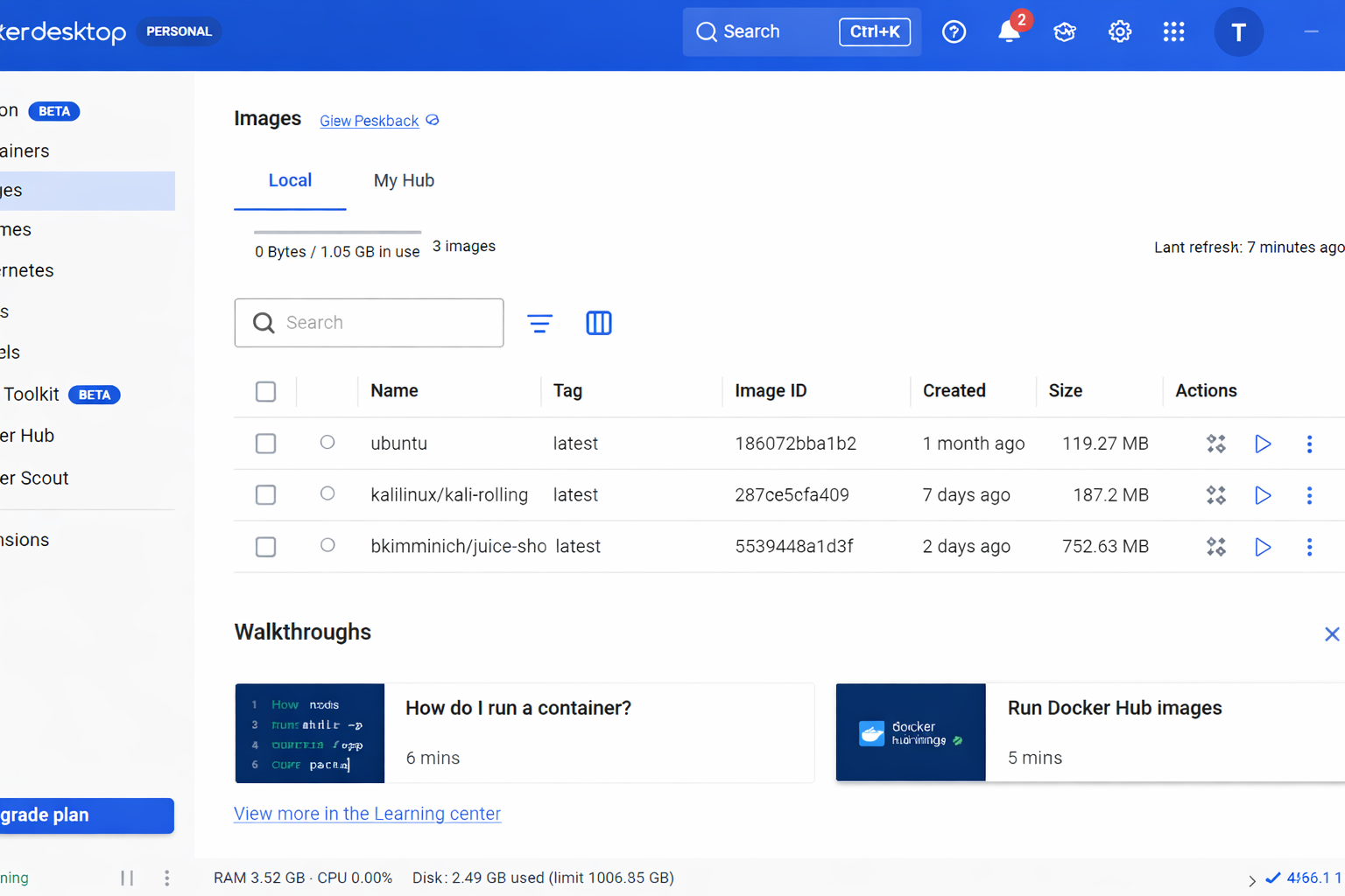

Setup Of Container :
1. Set Up the Kali Linux Container
• Pull the official Kali image:
docker pull kalilinux/kali-rolling
• Run Kali container:
docker run -it kalilinux/kali-rolling
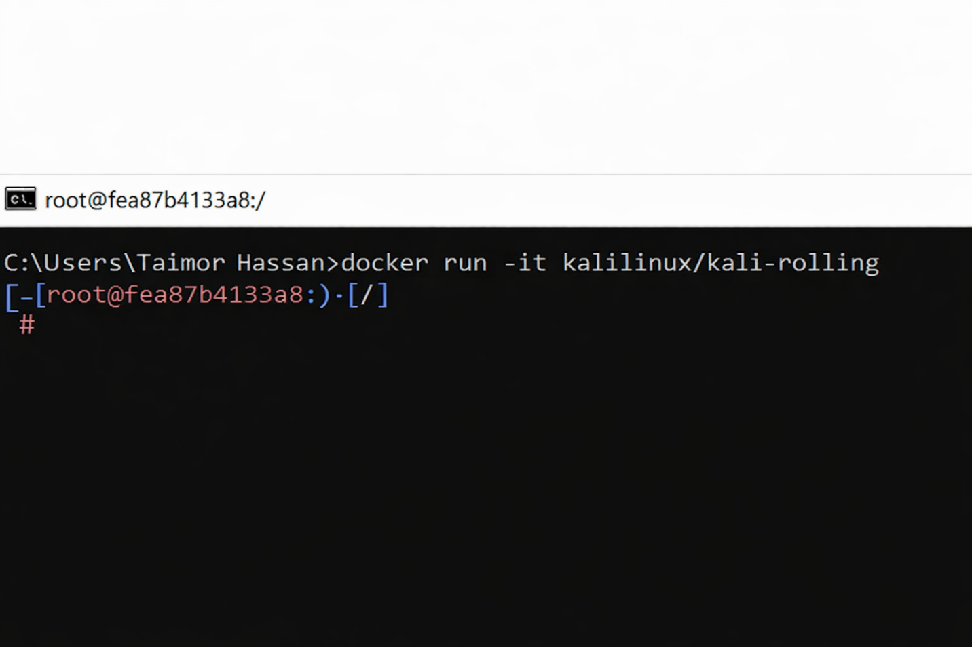
2. Set Up the Kali Linux Container
Ubuntu is a clean Linux environment for general tasks.
- Pull the latest Ubuntu image:
docker pull ubuntu:latest
- Run the container (interactive shell + network):
docker run -it Ubuntu

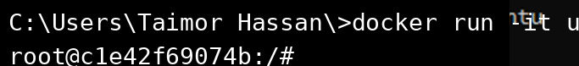

- Set Up OWASP Juice Shop (Vulnerable Web App)
OWASP Juice Shop is an intentionally insecure web application perfect for practicing OWASP Top 10 vulnerabilities.
- Pull the Juice Shop image:
docker pull bkimminich/juice-shop
- Run Juice Shop in detached mode with port mapping:
docker run -d -p 3000:3000 bkimminich/juice-shop
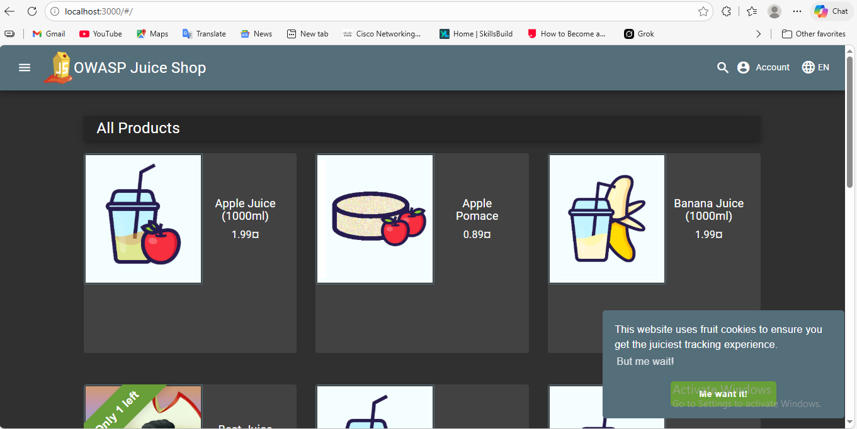

Showning Container
docker ps -a
Purpose: Shows running + stopped containers.
Show Running Containers
docker ps
Purpose: Shows only running containers.

7. Stopping a Container
docker stop <container_id>
Example:
docker stop 3f4a2b1c

8. Removing a Container
docker rm <container_id>
Purpose: Deletes container (must be stopped first).

9. Removing an Image
docker rmi <image_name>
Example:
docker rmi ubuntu
Purpose: Deletes image from system.

